Alarm: ID 21: Load Unit Not Found
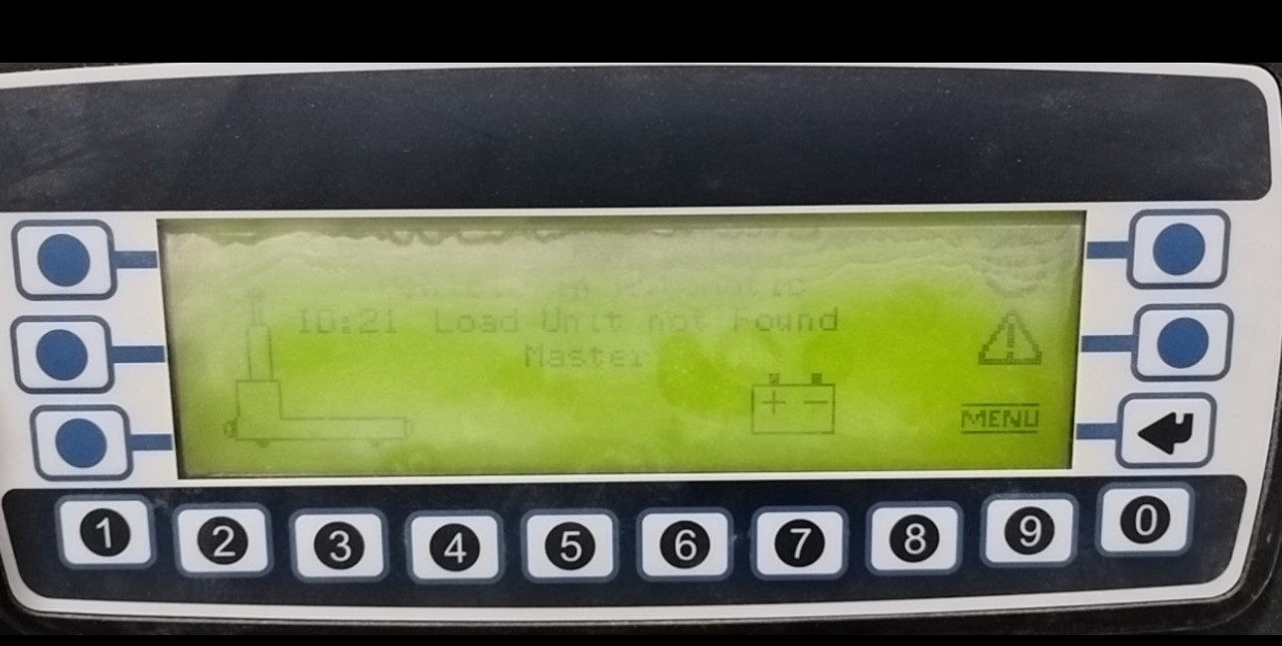
How To Fix:
This alarm occurs when the box sensor fails to make contact with the platform leg.
To resolve:
- Reposition the platform on the floor so the sensor can make contact with the platform leg.
If repositioning isn’t possible:
- Switch the AGV to Manual Mode and raise the table to its maximum height.
- Return the AGV to Automatic Mode.
- Press 1 on the AGV's front screen to load the platform.
For AGV routing adjustments:
- Cancel the existing mission on the AGV computer.
- Manually re-route the AGV's path.
- Rename the platform at its end destination with the correct number.
If you encounter issues, please contact a qualified AGV Technician.

